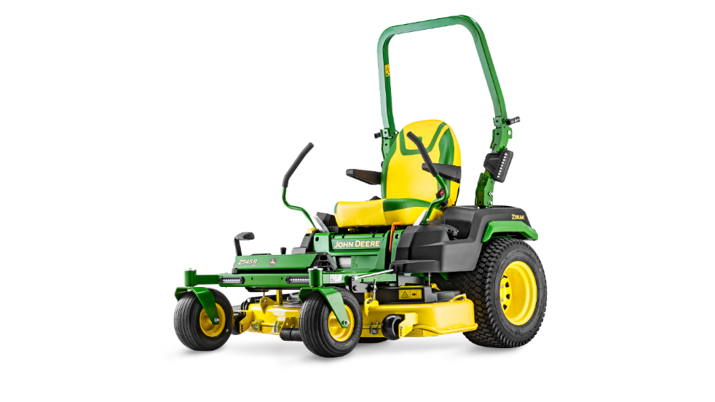
Z545 Zero Turn
- Easy to operate
- Highly Manoeuvrable
- Built Tough
- Faster Mowing Speeds : 14.5kph
- 15.3 kW 724cc engine
- 122 cm (48“) High Capacity Deck

Z335 Zero Turn

- Easy to operate
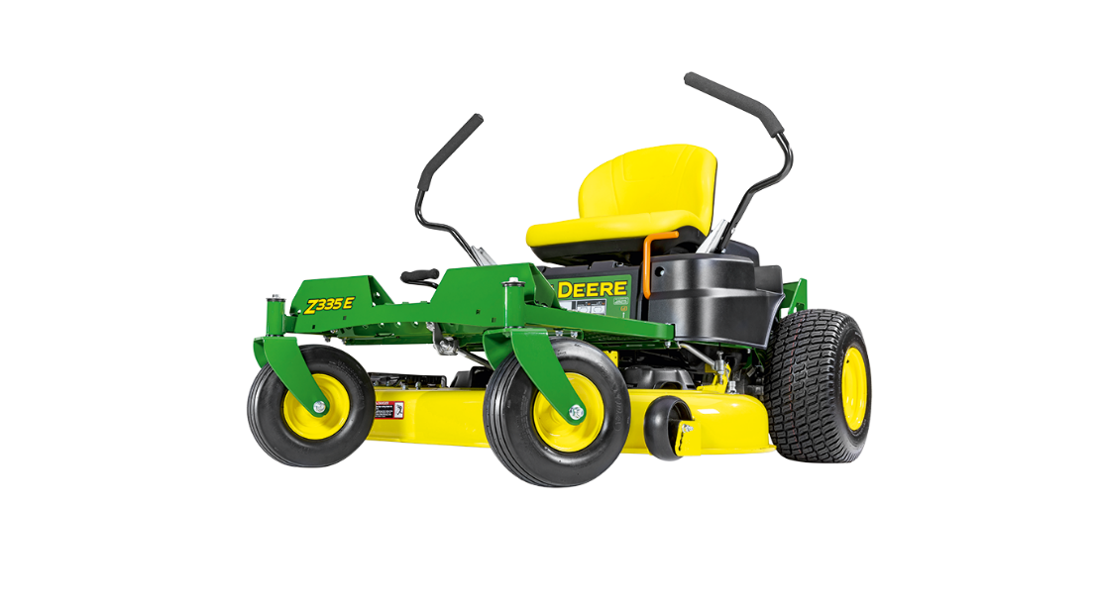
- Highly Manoeuvrable
- Built Tough
- Faster Mowing Speeds : 10.8kph
- 12.3 kW 656cc engine
- 107 cm (42“) Accel Deep™ Deck

